ONLINE EXAM SYSTEM
A MINI-PROJECT REPORT
Submitted by

JAAYISH EV 240701197
ASWIN SIDDHARTH A 240701064
FAIYAS N 240701135

in partial fulfillment of the award of the degree
of
BACHELOR OF ENGINEERING
IN
COMPUTER SCIENCE AND ENGINEERING

RAJALAKSHMI ENGINEERING COLLEGE, CHENNAI
An Autonomous Institute
CHENNAI
NOVEMBER 2025

BONAFIDE CERTIFICATE
Certified that this project “ONLINE EXAM SYSTEM” is the bonafide work of“JAAYISH.EV,ASWINSIDDHARTH.A, FAIYAS.N” who carried out the project work under my supervision.

SIGNATURE
Dr. J. MANORANJINI
Deputy Head Of The Department
Dept. of Computer Science and Engg,
Rajalakshmi Engineering College
Chennai

This mini project report is submitted for the viva voce examination to be held on __________

INTERNAL EXAMINER EXTERNAL EXAMINER
ABSTRACT

The Online Exam System is a web-based platform designed to streamline and modernize the process of conducting examinations. It enables educational institutions, training centers, and certification bodies to administer tests efficiently and securely over the internet. This system eliminates the need for physical infrastructure, reduces administrative overhead, and enhances accessibility for students across diverse locations.
Key features include question paper generation by staffs, randomized question delivery, real-time monitoring and instant result computation.
The system supports question format only multiple choice, customized for different subjects and difficulty levels.
It represents a significant shift toward digital education, offering a flexible, cost-effective, and eco-friendly alternative to traditional examination methods.

ACKNOWLEDGEMENT

We express our sincere thanks to our beloved and honorable chairman MR. S. MEGANATHAN and the chairperson DR. M.THANGAM MEGANATHAN for their timely support and encouragement.
We are greatly indebted to our respected and honorable principal
Dr. S.N. MURUGESAN for his able support and guidance.
No words of gratitude will suffice for the unquestioning support extended to us by our Head Of The Department Dr. E.M. MALATHY and our Deputy Head Of The Department Dr. J. MANORANJINI for being ever supporting force during our project work
We also extend our sincere and hearty thanks to our internal guide Dr. J. MANORANJINI , for her valuable guidance and motivation during the completion of this project.
Our sincere thanks to our family members, friends and other staff members of computer science engineering.
1. JAAYISH EV
2.ASWIN SIDDHARTH A
3. FAIYAS N

TABLE OF CONTENTS

CHAPTER NO. TITLE PAGE NO
ABSTRACT iv

1 INTRODUCTION 1
1.1 INTRODUCTION 8
1.2 SCOPE OF THE WORK 8
1.3 PROBLEM STATEMENT 8
1.4 AIM AND OBJECTIVES OF THE PROJECT 8
2 SYSTEM SPECIFICATIONS 9
2.1 HARDWARE SPECIFICATIONS 9
2.2 SOFTWARE SPECIFICATIONS 9
3 MODULE DESCRIPTION 10
4 CODING 11
5 SCREENSHOTS 16
6 CONCLUSION AND FUTURE ENHANCEMENT 18
REFERENCES 19

LIST of figures
FIGURE NO. | TITLE | PAGE NO.
5.1 | LOGIN PAGE | 15
5.2 | STUDENT REGISTRATION | 15
5.3 | TEACHER MANAGEMENT | 16
5.4 | ASSIGNING MCQ | 16
5.5 | EXAM RESULT | 17
5.6 | DATABASE CREATION | 17

CHAPTER 1
INTRODUCTION
  - INTRODUCTION
The Online Exam System is a digital platform for conducting exams remotely. It simplifies the examination process by automating question delivery and evaluation. Students can take tests from anywhere, making education more accessible. Security features like authentication and proctoring ensure exam integrity. This system is widely used in schools, universities, and corporate training.

1.2 SCOPE OF THE WORK
The Online Exam System encompasses the design, development, and implementation of a database-driven platform that facilitates the creation, management, and execution of online examinations. This project focuses primarily on the database aspects, ensuring efficient data handling, integrity, and security.
1.3 PROBLEM STATEMENT
Traditional examination methods are time-consuming, resource-intensive, and limited by location and infrastructure. Manual processes often lead to delays in evaluation, increased chances of human error, and difficulties in maintaining exam integrity. With the growing need for remote learning and scalable assessment solutions, there is a clear demand for a secure, efficient, and accessible Online Exam System that can automate and streamline the entire examination process.
1.4 AIM AND OBJECTIVES OF THE PROJECT
To develop a secure, efficient, and user-friendly Online Exam System that automates the process of conducting examinations, enhances accessibility, and ensures integrity in digital assessments.
CHAPTER 2
SYSTEM SPECIFICATIONS
2.1 HARDWARE SPECIFICATIONS
Processor | : | Intel i5
Memory Size | : | 8GB (Minimum)
HDD | : | 1 TB (Minimum)

2.2 SOFTWARE SPECIFICATIONS
Operating System | : | WINDOWS 10
Front – End | : | Java
Back - End | : | OracleDB
Language | : | Java,SQL

CHAPTER 3
MODULE DESCRIPTION
This application consists of three modules. When the program runs, it will ask for a confirmation to the login window. The person who interacts can login as an Administrator, Teacher or Student. The description of the modules are as follows:
- Admin login
When the person who interacts tries to login as Admin then he needs to login with his username and password. The administrator only has the power to change and manipulate the data in the database.
- Teacher login
When a staff tries to login he/she will be prompted to enter the user and their password. The teacher has access to assign MCQ’s and view results of the students.

- Student login
When a student tries to login they will be prompted to enter their username or Email-ID along with their password.The students have access to attend exams and view their result.

CHAPTER 4
SAMPLE CODING
from tkinter import *
import sqlite3
import pyttsx3
# connection to database
conn = sqlite3.connect('database.db')
c = conn.cursor()
# empty lists to append later
number = []
patients = []
sql = "SELECT * FROM appointments"
res = c.execute(sql)
for r in res:
ids = r[0]
name = r[1]
number.append(ids)
patients.append(name)
# window
class Application:
def __init__(self, master):
self.master = master
self.x = 0
# heading
self.heading = Label(master, text="Bookings", font=('arial 60 bold'), fg='green')
self.heading.place(x=450, y=50)
# button to change bookings
self.change = Button(master, text="Next Booking", width=25, height=2, bg='steelblue', command=self.func)
self.change.place(x=500, y=550)
# empty text labels to later config
self.n = Label(master, text="", font=('arial 80 bold'))
self.n.place(x=500, y=210)
self.pname = Label(master, text="", font=('arial 80 bold'))
self.pname.place(x=500, y=320)
# function to speak the text and update the text
def func(self):
y = str(number[self.x] - 25)
self.n.config(text=str(y))
self.pname.config(text=str(patients[self.x]))
engine = pyttsx3.init()
voices = engine.getProperty('voices')
rate = engine.getProperty('rate')
engine.setProperty('rate', rate-30)
engine.say('Booking number ' + str(y) + str(patients[self.x]))
engine.runAndWait()
self.x += 1
root = Tk()
b = Application(root)
root.geometry("1530x780+0+0")
root.resizable(False, False)
root.mainloop()
Sample 1
Sample 1 depicts the display code, that gets the data from the database i.e. being stored there and represented on users demand with the layout and measurements i.e. being already specified.
from tkinter import *
import tkinter.messagebox
import sqlite3
import sys
conn = sqlite3.connect('database.db')
c = conn.cursor()
class Application:
def __init__(self, master):
self.master = master
# heading label
self.heading = Label(master, text="Bookings ", fg='grey', font=('arial 40 bold'))
self.heading.place(x=550, y=20)
# search criteria -->name
self.name = Label(master, text="Enter Owner's Name", font=('arial 20 bold'))
self.name.place(x=400, y=142)
# entry for the name
self.namenet = Entry(master, width=35)
self.namenet.place(x=800, y=150)
# search button
self.search = Button(master, text="Search", width=14, height=2, bg='steelblue', command=self.search_db)
self.search.place(x=700, y=210)
def search_db(self):
self.input = self.namenet.get()
# execute sql
sql = "SELECT * FROM appointments WHERE name LIKE ?"
self.res = c.execute(sql, (self.input,))
for self.row in self.res:
self.name1 = self.row[1]
self.age = self.row[2]
self.gender = self.row[3]
self.location = self.row[4]
self.phone = self.row[5]
self.phone = self.row[6]
Sample 2
Sample 2 depicts the booking part of the code, where it displays booking details and enter user data and store it in database
CHAPTER 5
SCREEN SHOTS
Fig 5.1 Login page
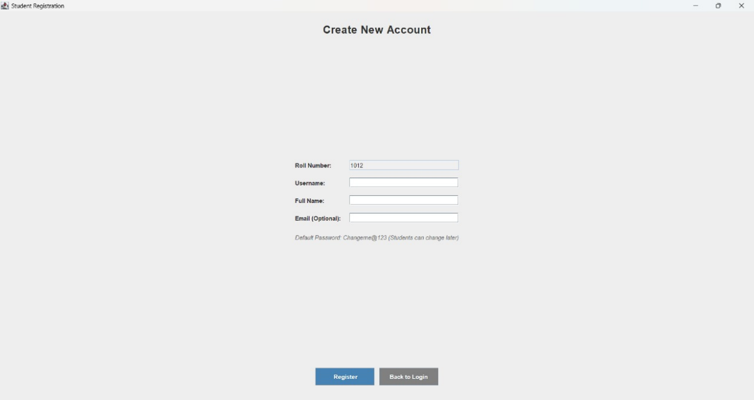
Fig 5.2 Student Registration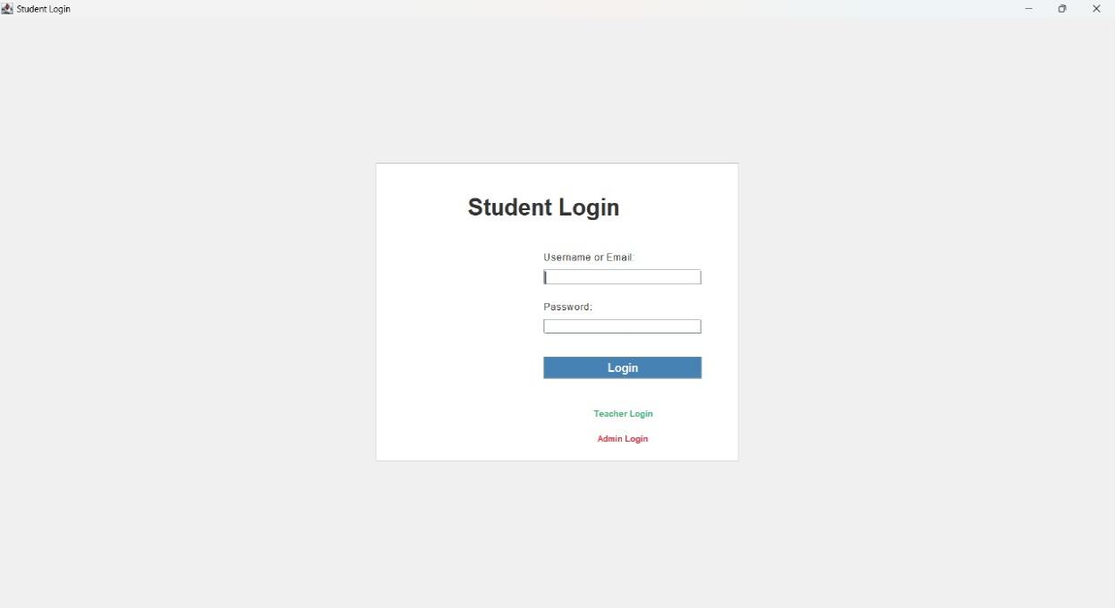

Fig 5.3 Teacher Management
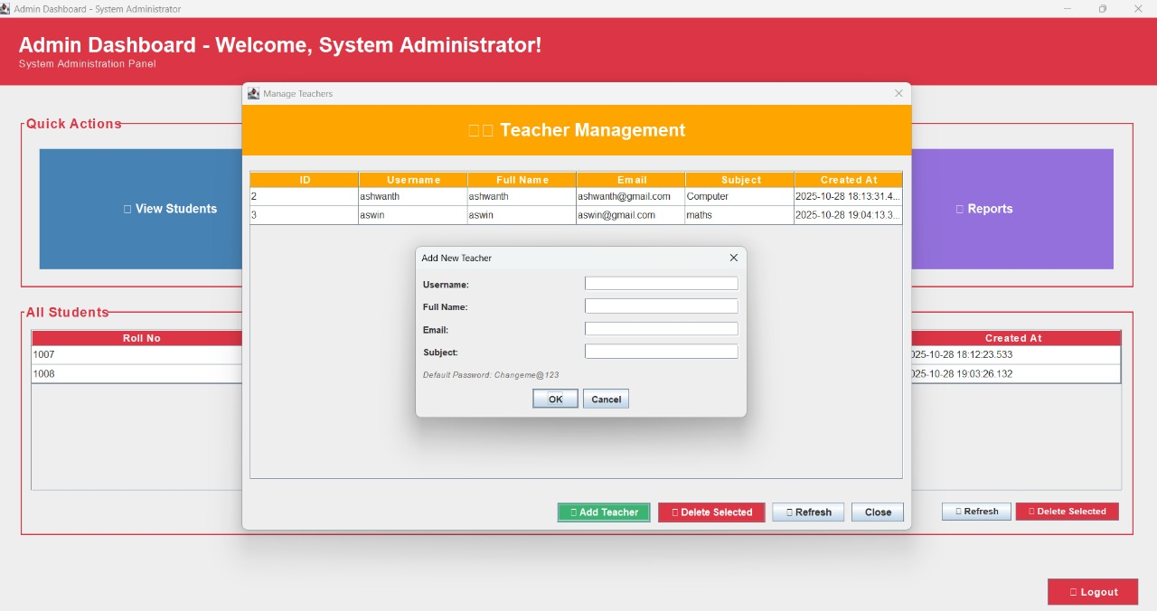

Fig 5.4 Assigning MCQ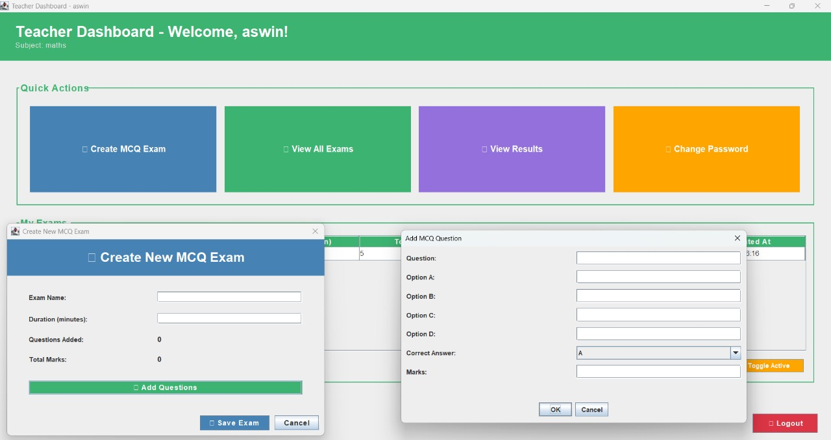

Fig 5.5 Exam Result 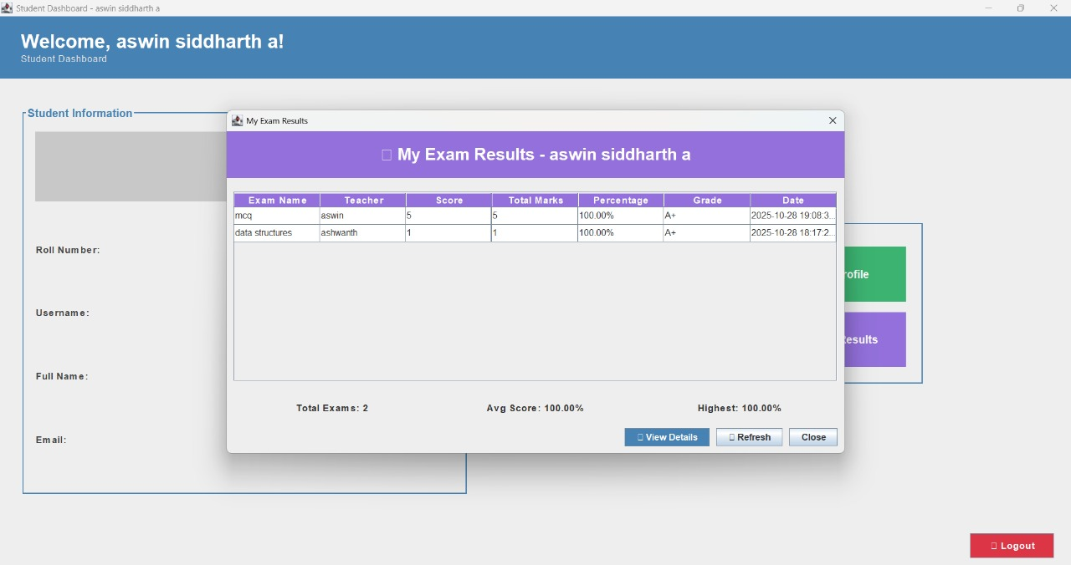
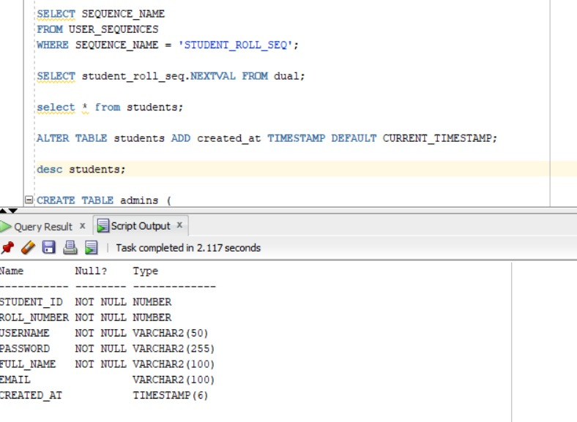

Fig 5.6 Database creation

CHAPTER 6
CONCLUSION AND FUTURE ENHANCEMENT
The Online Exam System successfully streamlines the examination process by offering a secure, efficient, and accessible platform for conducting tests remotely. It reduces administrative workload, minimizes human error, and ensures fairness through automated evaluation and anti-cheating measures. This system proves to be a valuable tool for educational institutions and training centers in the digital age.

REFERENCES
- https://www.w3schools.com/sql/
- https://www.tutorialspoint.com/sqlite/index.htm
- https://www.wikipedia.org/
- https://www.learnpython.org/
- https://www.codecademy.com/learn/learn-python

